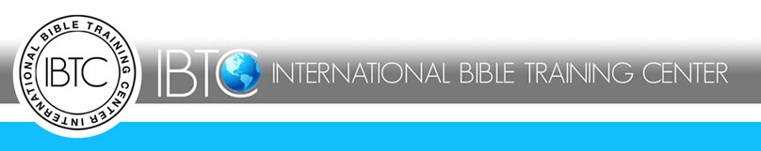
Payment Agreement Form

Please complete this form in its entirety.
This serves to confirm that I am aware that International Bible Training Center has a policy that requires each student following the payment plan to strictly adhere to the agreement as laid forth below.
Please select one of the payment schedules below:
Annually: $1200.0
Quarterly: $310.00
Monthly: $105.00

Therefore, I agree to render payment in accordance to the above agreement. Payment is due on the 1st Tuesday of each month but no later than the 2nd Tuesday of each month unless prearranged with the Administration Office.
I, ___________________________________________________, hereby consent to follow the payment agreement with strict adherence. I have read and understood the conditions of the agreement; should I have any difficulty, I fully accept it as my responsibility to report this matter to the IBTC Administration Office before the next payment is due, so as to allow for alternate arrangements to be made.

_________________________________________ _________________________
Printed Name Date

_________________________________________ __________________________
Signature Date

_________________________________________ __________________________
IBTC Representative Date

